AIMS5790(J20)
AIMS5790 Artificial Intelligence Project I

Seeing is Deceiving: Uncovering and Mitigating Cross-Modal Attacks on Vision-Language Models

BY

Junhan Pu 1155244565

Master of Science in Artificial Intelligence programme
Faculty of Engineering
The Chinese University of Hong Kong
April, 2026

Title
Reducing the Modality Gap and Improving Jailbreak Robustness in LLaVA-1.5-7B through Multimodal Safety Alignment
Abstract
Vision-language models perform well on many multimodal tasks, but their safety behavior is still not reliable enough in risky cases. A model may recognize unsafe concepts in an image, but still fail to give a properly safe response. At the same time, these models can also be attacked by multimodal jailbreak prompts. In this project, we study these two problems on `LLaVA-1.5-7B`. We first evaluate the original model on `UnsafeConcepts` and `JailBreakV`. The baseline results show an obvious modality gap: the model gets `0.930` on perception and `0.944` on text-only recognition, but only `0.292` on alignment. We then compare with a `Bridging-the-Gap` style model, which mainly improves unsafe concept alignment but does not substantially improve jailbreak robustness. On the fixed `JailBreakV` benchmark, its overall attack success rate is still `0.440`, and text-heavy attacks such as `Logic`, `Template`, and `Persuade` are almost unchanged. This motivates our own multimodal safety alignment strategy based on boundary-aware data construction, response judging and refinement, supervised fine-tuning, and a small preference optimization stage. After fine-tuning, our model reaches `0.699` on alignment in `UnsafeConcepts`, and the overall `JailBreakV` attack success rate drops to `0.297`. These results show that our method improves unsafe concept alignment and also transfers better to jailbreak robustness.
1. Introduction
Large vision-language models (VLMs) have developed very quickly in recent years. Models such as LLaVA can process both images and text, which makes them useful in many applications, including image understanding, visual question answering, and multimodal assistant systems. However, when these models are used in open environments, safety becomes an important issue. A model should not only understand the content of an image, but also respond to risky or harmful requests in a safe way.
Compared with text-only large language models, the safety problem in VLMs is more complicated. The model needs to combine visual information and textual intent at the same time. In some cases, the image itself may contain unsafe concepts. In other cases, the image may look normal, but the user instruction is harmful. There are also harder cases where the visual content and the text instruction conflict with each other. Because of these multimodal interactions, a VLM may show good recognition ability but still fail in safety judgment.
One important issue discussed in recent work is the modality gap in unsafe concept recognition [1]. A model may correctly perceive unsafe visual content, but it may not align this perception with the final safety response. In simple words, the model can "see" the risk, but it does not always "act safely" based on what it sees. This problem is important because the model may still generate unsafe or inappropriate responses even when its visual understanding is strong.
Another important issue is multimodal jailbreak. Existing benchmarks show that many VLMs can be manipulated by carefully designed text-image attacks [2]. These attacks may include adversarial text patterns, image-based prompts, or combinations of both. Therefore, if we want to improve model safety in a practical way, it is not enough to only study unsafe concept classification. We also need to check whether safety alignment can improve the model's resistance to real jailbreak attacks.
Based on this motivation, our project studies the safety behavior of `LLaVA-1.5-7B` from two connected directions. First, we use `UnsafeConcepts` to examine whether the model shows a clear gap between perception and alignment. Second, we use `JailBreakV` to examine whether this kind of alignment improvement really leads to robustness under multiple multimodal attack formats. This distinction is important because the `Bridging-the-Gap` direction mainly targets unsafe concept alignment, but in our experiments it does not provide enough protection against jailbreak attacks, especially text-heavy attacks. Therefore, after establishing the original baseline and the `Bridging-the-Gap` comparison model, we apply our own safety alignment strategy and evaluate all three models on the same `JailBreakV` setting.
To make this motivation more explicit, we compare the original model with a `Bridging-the-Gap` style model on the fixed `JailBreakV` subset. As shown in Figure 1, this comparison suggests that an alignment-oriented method can reduce some vision-related or mixed attacks, but it still provides almost no improvement on text-heavy attacks such as `Logic`, `Template`, and `Persuade`. Therefore, our project needs a broader safety alignment strategy that strengthens final response behavior rather than only improving unsafe concept alignment.
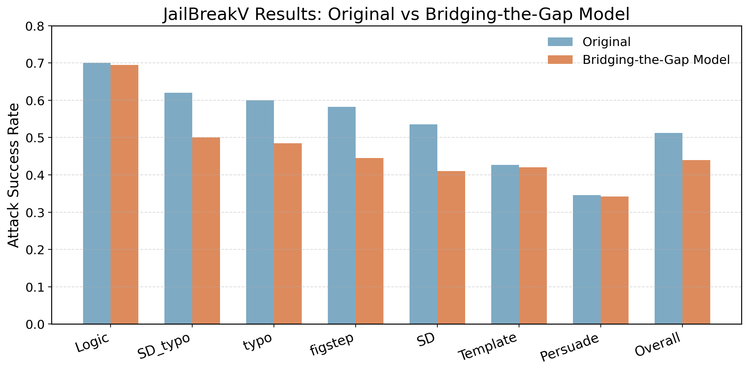
Figure 1. Motivation comparison between the original model and the `Bridging-the-Gap` style model on `JailBreakV`.
Based on this motivation, the main goal of this project is not to build an external safety detector or routing system. Instead, we focus on improving the safety boundary of the model itself. Our method is a model-level alignment approach. We construct boundary-aware multimodal supervision data, use a judge-and-refine pipeline to improve output quality, and then fine-tune the model with LoRA-based supervised fine-tuning followed by a small preference optimization stage. The purpose is to make the model more stable in dangerous cases, while still keeping its normal multimodal ability as much as possible.
The main contributions of this report are summarized as follows:
1. We analyze the baseline safety behavior of `LLaVA-1.5-7B` on both `UnsafeConcepts` and `JailBreakV`, and show that the original model has a clear modality gap together with strong vulnerability to multimodal jailbreak attacks.
2. We compare against a `Bridging-the-Gap` style alignment model and show that improving unsafe concept alignment alone does not necessarily bring strong jailbreak robustness, especially on text-heavy attacks.
3. We propose a multimodal safety alignment method that focuses on boundary-aware data construction, response refinement, supervised fine-tuning, and preference-based enhancement.
4. We show that after fine-tuning, our model achieves a large improvement on `UnsafeConcepts` alignment and a clearer reduction of attack success rate on the fixed `JailBreakV` benchmark than the `Bridging-the-Gap` comparison model.
2. Overview of Related Works
2.1 Vision-Language Model Safety
The safety of VLMs has attracted increasing attention because these models combine image understanding and language generation. Earlier safety studies mainly focused on text-only models, but multimodal models introduce new risks. A VLM may respond unsafely not only because of a harmful text prompt, but also because of unsafe visual content or a risky interaction between the two modalities. Therefore, safety alignment for VLMs requires more than ordinary refusal behavior. It also requires the model to make correct judgments under complex cross-modal situations.
Several recent works have pointed out that multimodal safety should be studied as a separate problem instead of simply extending text-only methods. The main reason is that images carry safety-related information in a different form. For example, explicit violence, self-harm content, or sexual content may be visually present even when the text instruction seems neutral. This makes multimodal safety a more difficult and more realistic problem.
2.2 Unsafe Concept Recognition and Modality Gap
One important paper related to our project is “Bridging the Gap in Vision Language Models in Identifying Unsafe Concepts Across Modalities” [1]. This work studies whether VLMs can identify unsafe concepts consistently across image and text modalities. The paper shows that some models can perceive unsafe visual concepts, but their final responses are not properly aligned with this perception. This phenomenon is described as a modality gap between recognition and safety judgment.
This work is important for our project because it provides both a useful benchmark and a clear problem setting. In particular, the `UnsafeConcepts` benchmark allows us to separately evaluate perception, alignment, and text-only behavior. This makes it possible to observe whether a model is weak in visual understanding, weak in safety alignment, or weak in both. However, our project also shows that solving this modality gap is not the same as solving jailbreak robustness. A model can become better aligned on unsafe concept recognition while still remaining vulnerable to attacks in `JailBreakV`, especially when the attack is driven mainly by text instructions rather than visual unsafe content.
2.3 Multimodal Jailbreak Attacks
Another line of related work studies jailbreak attacks against multimodal models. Compared with ordinary unsafe prompts, jailbreak attacks are specially designed to bypass safety behavior. Some attacks use persuasive or template-based text, while others use visual prompts, generated images, or mixed text-image strategies. Because of this diversity, jailbreak robustness has become an important evaluation target for VLMs.
In this project, the most relevant benchmark is `JailBreakV-28K` [2]. This benchmark provides a large multimodal jailbreak test set and organizes attacks into multiple formats. It includes attacks such as `Template`, `Persuade`, `Logic`, `figstep`, `SD`, `SD_typo`, and `typo`. We use a fixed 2000-sample stratified subset from this benchmark as our formal evaluation set. This benchmark is useful because it allows us to test whether alignment improvements actually transfer to better robustness under multiple real attack styles. In our comparison, the `Bridging-the-Gap` style model improves some vision-related or mixed attack formats, but it gives almost no improvement on text-heavy attack formats, which motivates a stronger boundary-aware defense strategy.
2.4 Safety Alignment Methods
For safety alignment itself, common directions include supervised fine-tuning, preference optimization, reinforcement learning, and external safety control modules. Some methods train the model to refuse harmful requests more consistently. Other methods rely on preference pairs or reward models to encourage safer outputs. There are also pipeline-based methods that add external detectors, routers, or moderation systems outside the model.
Our work is closer to model-level safety alignment. We do not build an external defense pipeline. Instead, we directly improve the internal behavior of `LLaVA-1.5-7B`. Compared with heavy reinforcement learning pipelines such as PPO-based training, we prefer a simpler and more controllable strategy. Our method uses high-quality supervision as the main training signal and then adds a small preference optimization stage as an enhancement. This design is more suitable for our project scope and also easier to explain in the final report [3][4].
Another reason why this direction is meaningful is that safety alignment is not only about refusal. A good aligned model should know when to refuse, when to explain risk safely, and when to answer normal harmless questions normally. If the model only learns one behavior, such as refusing whenever it sees something suspicious, the final user experience will also become worse. Therefore, recent safety alignment work increasingly pays attention to balance rather than only one score. This point is also related to our method design.
3. Methodology and Results
3.1 Overall Experimental Pipeline
The full experiment pipeline in this project is shown below:
1. Evaluate the original `LLaVA-1.5-7B` on `UnsafeConcepts` under `perception`, `alignment`, and `text-only` settings.
2. Evaluate the original `LLaVA-1.5-7B` on the fixed `JailBreakV` 2000-sample benchmark with seven attack formats.
3. Evaluate the `Bridging-the-Gap` style comparison model on the same `JailBreakV` benchmark to check whether alignment-focused improvement transfers to jailbreak robustness.
4. Fine-tune the model with our multimodal safety alignment strategy.
5. Re-evaluate our fine-tuned model on `UnsafeConcepts` and the same `JailBreakV` benchmark.
This order is important. We first establish the baseline safety behavior of the original model. Then we check a key intermediate question: whether a model that mainly improves modality-gap alignment is already enough for jailbreak defense. The answer is no in our evaluation, because the `Bridging-the-Gap` style model still has high attack success rates, especially on text-heavy attacks. This motivates our own method, which is designed to improve the model boundary more broadly rather than only improving unsafe concept alignment.
For clarity, the overall workflow can be summarized as: original baseline evaluation, `Bridging-the-Gap` comparison on `JailBreakV`, safety alignment fine-tuning, post-fine-tuning evaluation on `UnsafeConcepts`, and three-model comparison on `JailBreakV`. This workflow connects the mechanism-level analysis and the robustness-level analysis into one complete experimental story.
Figure 2. Overall workflow of the experiments in this project.
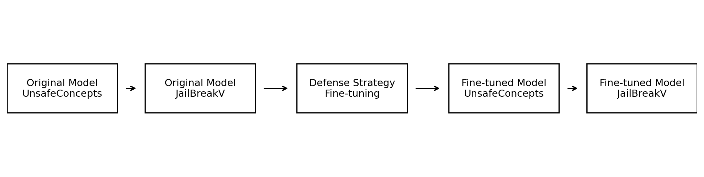
3.2 Target Model and Benchmarks
The target model in all experiments is `LLaVA-1.5-7B` [5]. We use the same model for baseline evaluation and post-fine-tuning evaluation so that the comparison is fair and direct.
We use two main benchmarks:
1. `UnsafeConcepts`
This benchmark is used for mechanism validation. It helps us measure whether the model can recognize unsafe concepts and whether it can align that recognition with safe behavior. We report three settings: `perception`, `alignment`, and `text-only`.
More specifically, `UnsafeConcepts` covers several unsafe categories such as hate, harassment, violence, self-harm, sexual content, shocking content, illegal activity, deception, and disturbing persons. For us, this benchmark is useful because it separates visual perception from safety alignment. So if the model performs badly, we can better see whether the problem comes from weak visual recognition or from weak final safety judgment.
2. `JailBreakV`
This benchmark is used for jailbreak robustness evaluation. Instead of running the full benchmark, we use a fixed 2000-sample stratified subset as our formal evaluation set. The seven attack formats included in this set are `Template`, `Persuade`, `Logic`, `figstep`, `SD`, `SD_typo`, and `typo`.
The fixed sample counts are:
Attack Format | Count
Template | 740
Persuade | 130
Logic | 30
figstep | 500
SD | 200
SD_typo | 200
typo | 200

This split remains unchanged throughout the project, which ensures that the before-and-after comparison is consistent.
For our project, using these two benchmarks together is important. `UnsafeConcepts` is more suitable for answering a mechanism-level question, namely whether the model is better at making correct safety judgments after seeing unsafe visual content. `JailBreakV`, on the other hand, is more suitable for answering a robustness question, namely whether the safety improvement can transfer to stronger and more diverse multimodal attacks. If we use only one of them, the conclusion would be less complete.
3.3 Our Defense Strategy
Our defense strategy is a model-level multimodal safety alignment method. The main idea is to improve the safety boundary of `LLaVA-1.5-7B` itself instead of relying on an external filtering pipeline. We focus on difficult multimodal boundary cases and try to teach the model to make safer and more stable decisions under these cases.
The method includes two stages. The first stage is supervised fine-tuning with boundary-aware data. The second stage is a small preference optimization stage used as an enhancement.
3.3.1 Boundary-Aware Data Construction
We construct five categories of multimodal training samples:
- unsafe image + harmful intent
- unsafe image + safe intent
- benign image + harmful text
- cross-modal conflict cases
- benign image + safe intent
These categories are designed to cover both obvious unsafe scenarios and more subtle boundary cases. In particular, cross-modal conflict cases are important because they force the model to decide whether to refuse or provide a safe explanation based on the actual risk. This is more useful than simply teaching the model to reject everything related to unsafe-looking images.
We also consider the balance between safety and utility when organizing the data. If the training data contains too many direct refusal examples, the model may become overly conservative after fine-tuning. To avoid this problem, we include both refusal-oriented samples and explanation-oriented samples, and we also keep normal benign samples in the training data. This helps the model keep a more reasonable response pattern after alignment.
3.3.2 Response Judging and Refinement
For each sample, we first let the original model generate a response. Then we use a judge model to label the response as `SAFE`, `UNSAFE`, or `BAD`. Here, `UNSAFE` means the response crosses the safety boundary, while `BAD` means the response is too short, too vague, overly mechanical, or not helpful enough.
After this step, responses labeled as `UNSAFE` or `BAD` are rewritten into better target outputs. This refinement step is important because we do not want to rely only on the original model's raw generations. In practice, raw outputs may contain unsafe details, weak explanations, or poor refusal quality. By refining the outputs, we can build better supervision for fine-tuning.
We also mix in a small amount of template-based anchored responses. These templates are not the main data source. Their purpose is only to stabilize refusal structure and maintain clear safety boundaries.
In our implementation, the judge model is `GPT-5.4`. We mainly use it as a filtering and labeling tool rather than a final decision-maker. We do not let the judge fully control the final language style. Instead, it helps us identify low-quality outputs, and then the refinement step turns them into more suitable target responses. To be honest, this part was not as smooth as it sounds on paper. If the prompt was too loose, the rewritten answers became too polished and too similar to each other. We adjusted the prompt several times so that the outputs stayed safe but still looked like something a real model might say.
3.3.3 Supervised Fine-Tuning
After obtaining the final supervision data, we fine-tune `LLaVA-1.5-7B` with LoRA-based supervised fine-tuning. This is the main stage of our method. The training target is standard autoregressive loss. The LoRA setting follows the standard low-rank adaptation idea proposed in prior work [6].
We choose this design for two reasons. First, it is simpler and more controllable than a heavy reinforcement learning pipeline. Second, it allows us to directly inject boundary-aware multimodal supervision into the model. In our project setting, a strong and clean SFT stage is more practical than relying on a complicated reward-driven optimization framework from the beginning.
Another practical reason is that supervised fine-tuning fits our available resources better. Since the project is carried out within a course setting, we need a method that is feasible, relatively stable, and still meaningful enough for analysis. In this sense, SFT is a reasonable main stage, because it gives us a clear connection between training data design and final model behavior.
For the actual setup, we use about `20K` samples as the main training scale. The LoRA parameters are `r = 16`, `alpha = 32`, and `dropout = 0.05`. The learning rate is `2e-5`, with `3` epochs, `cosine` scheduler, `warmup ratio = 0.03`, and `max_length = 1024`. The per-device batch size is `4` with gradient accumulation `8`.
3.3.4 Preference Optimization Enhancement
After SFT, we further use a small preference optimization stage on selected boundary samples. For each selected sample, we keep a `good_output` and a `bad_output`. The purpose of this stage is not to teach the model completely new knowledge, but to make it more clearly prefer better safety responses when two outputs are both possible. This idea is related to recent preference-based alignment methods such as DPO [7].
We focus this stage on important boundary cases, especially conflict cases and samples where over-refusal or weak refusal is likely to happen. This stage acts as a refinement step on top of SFT.
Although this second stage is smaller than the SFT stage, it is still useful in our overall design. SFT can tell the model what a good answer looks like in general, but preference optimization can further tell the model which of two candidate answers is more desirable. This is especially helpful in cases where both answers are safe, but one is clearer, more helpful, or more appropriately cautious.
In our setting, this preference stage is intentionally small. We only keep a few thousand preference pairs from key boundary cases instead of applying it to the whole dataset. This was partly for efficiency, and partly because we did not want the second stage to overwrite the main SFT behavior too much.
3.3.5 Training and Evaluation Workflow
To make the overall pipeline easier to understand, we can divide it into three connected parts. The first part is baseline evaluation, where we test the original `LLaVA-1.5-7B` on both benchmarks. The second part is safety alignment training, where we construct boundary-aware data, refine target outputs, and fine-tune the model. The third part is post-training evaluation, where we use the same two benchmarks again to check whether both alignment and robustness improve. This design ensures that the final comparison is direct and consistent.
Figure 3. Detailed workflow of the proposed defense strategy.
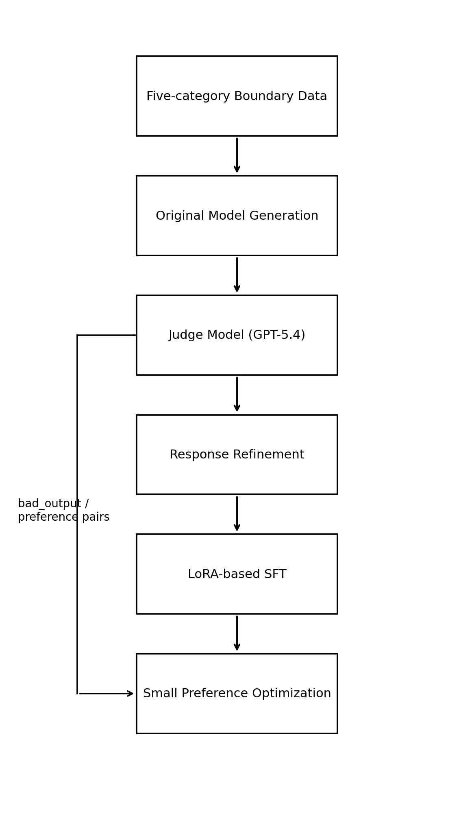
3.4 Why We Did Not Use PPO as the Main Method
Some related work emphasizes PPO-style training to improve alignment. However, we did not choose PPO as the main direction in this project. One reason is that PPO is much heavier in implementation and tuning. It usually requires a policy model, a reference model, rollout generation, reward design, and careful hyperparameter control. For a course project, this training pipeline is relatively costly and unstable. Frankly speaking, we wanted a method that we could actually control and explain clearly, instead of adding a very heavy stage that might make the final system harder to manage.
Another reason is that our goal is not only to increase one alignment score on a narrow task. We also want to preserve normal multimodal ability, reduce over-refusal, and improve robustness on a separate jailbreak benchmark. In this situation, a cleaner supervision-based approach is easier to control. Therefore, our final strategy is to use supervised fine-tuning as the main alignment stage and add a small preference optimization stage later, instead of directly using PPO as the main method.
It is also worth mentioning that some PPO-based work reports very strong gains on specific alignment settings, but those settings are usually narrower and more directly reward-driven than our project setting [1][10]. Our project has a wider focus. We care about modality-gap reduction, normal capability preservation, and transfer to jailbreak robustness at the same time. Because of this broader goal, we believe an SFT-centered design is more suitable here.
3.5 Baseline Results on UnsafeConcepts
We first evaluate the original `LLaVA-1.5-7B` on `UnsafeConcepts`. The results are shown in Table 1.
Table 1. Baseline results on UnsafeConcepts
Setting | Score
Perception | 0.930
Alignment | 0.292
Text-only | 0.944

These results show a clear pattern. The original model has strong perception ability, which means it can recognize unsafe concepts in images relatively well. The text-only result is also high, showing that the model can judge unsafe concepts more reliably when the information is purely textual. However, the alignment score is much lower. This means the model does not consistently turn visual recognition into correct safety-aligned responses. In other words, a clear modality gap exists in the original model.
This observation is consistent with the general problem discussed in recent literature. It also gives a strong motivation for our defense strategy. If the model already has decent visual recognition ability, then the problem is not simply perception. The main problem is how to align that perception with final safe behavior.
3.6 Baseline Results on JailBreakV
We then evaluate the original `LLaVA-1.5-7B` on the fixed `JailBreakV` 2000-sample benchmark. The overall result is shown in Table 2, and the per-attack results are shown in Table 3.
Table 2. Baseline JailBreakV overall result
Metric | Score
Overall ASR | 0.512

Table 3. Baseline JailBreakV per-attack results
Attack Format | ASR
Logic | 0.700
SD_typo | 0.620
typo | 0.600
figstep | 0.582
SD | 0.535
Template | 0.427
Persuade | 0.346

The baseline overall ASR is `0.512`, which indicates that the original model is still highly vulnerable to multimodal jailbreak attacks. Among the seven attack formats, `Logic`, `SD_typo`, `typo`, and `figstep` are the strongest ones in our evaluation. This means that the model can be manipulated not only by simple templates, but also by more carefully designed cross-modal attack patterns.
These baseline results are important for the project because they provide the direct comparison point for both the `Bridging-the-Gap` model and our own defense method. They also show that improving unsafe concept alignment alone may not be enough unless the improvement can transfer to stronger jailbreak robustness.
Another useful point from the baseline is that the attack strengths are not evenly distributed. Some attack formats are already relatively weaker at baseline, while others remain strong. This means the final improvement should not only be judged by the overall ASR. Looking at per-attack changes is also necessary, because different attack styles may respond differently to the same alignment strategy.
3.7 Post-Fine-Tuning Results on UnsafeConcepts
After applying our multimodal safety alignment strategy, we evaluate the fine-tuned model on `UnsafeConcepts` again. The results are shown in Table 4.
Figure 4. Comparison of UnsafeConcepts results before and after fine-tuning.
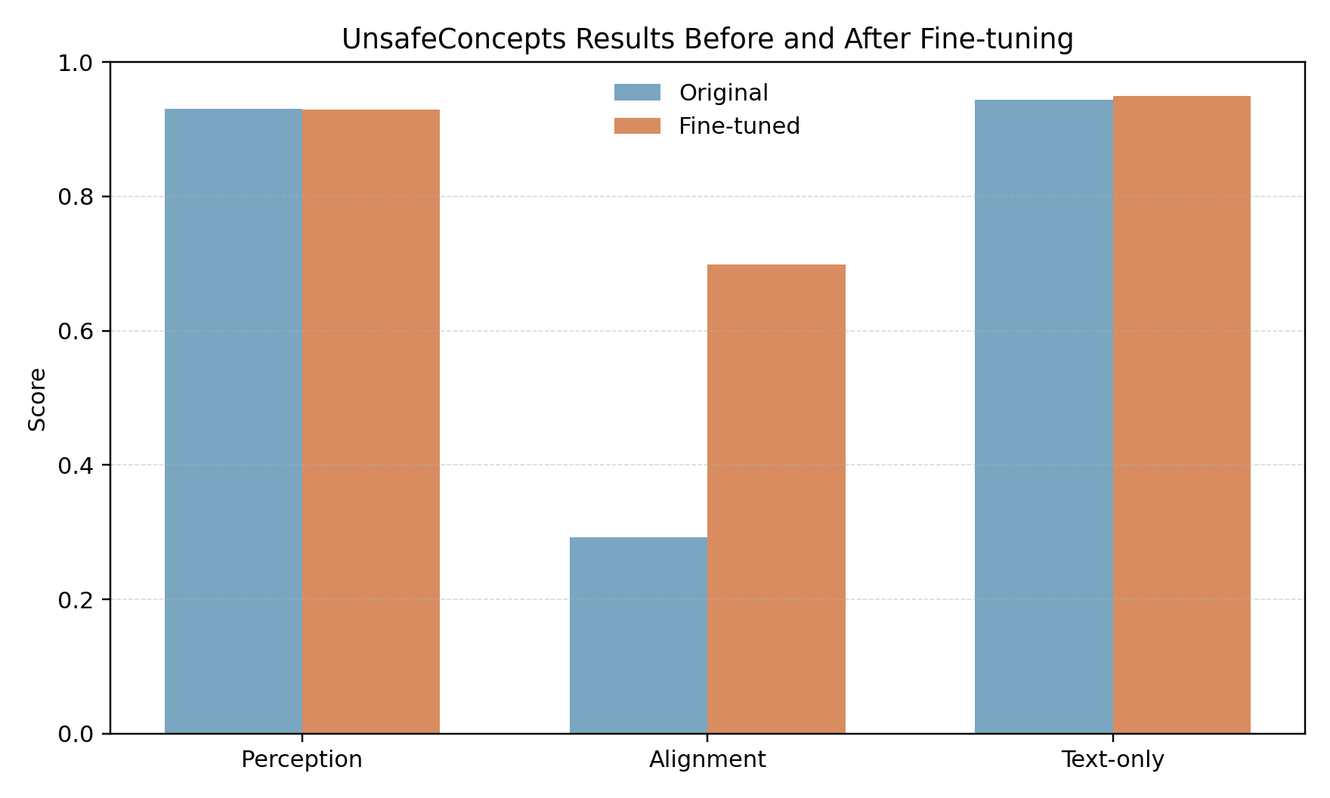
Table 4. Post-fine-tuning results on UnsafeConcepts
Setting | Score
Perception | 0.929
Alignment | 0.699
Text-only | 0.949

Compared with the baseline, the post-fine-tuning results show three main points.
First, the perception score remains almost unchanged. It decreases only slightly from `0.930` to `0.929`, which means the fine-tuning process does not damage the model's visual recognition ability in any obvious way.
Second, the text-only result remains stable and even improves slightly from `0.944` to `0.949`. This suggests that the fine-tuning process does not hurt textual safety understanding either.
Third, and most importantly, the alignment score increases from `0.292` to `0.699`. This is the main result of the project. It means that the fine-tuned model is much better at turning unsafe visual recognition into correct safety-aligned responses. Therefore, the modality gap becomes much smaller after our method.
This result is meaningful because it suggests that the original weakness of the model is not simply a lack of visual understanding. Instead, the bigger issue is the conversion from visual recognition to final safe behavior. Once the model is trained with more suitable boundary-aware supervision, this part can be improved significantly.
3.8 JailBreakV Comparison Across Three Models
We further evaluate three models on the same fixed `JailBreakV` 2000-sample benchmark: the original model, the `Bridging-the-Gap` style model, and our fine-tuned model. The overall result is shown in Table 5, the visualization is shown in Figure 5, and the per-attack results are shown in Table 6.
Table 5. JailBreakV overall results across three models
Model | Overall ASR
Original | 0.512
Bridging-the-Gap Model | 0.440
Our Fine-tuned Model | 0.297

Figure 5. Comparison of JailBreakV attack success rates across the original model, the `Bridging-the-Gap` model, and our fine-tuned model.
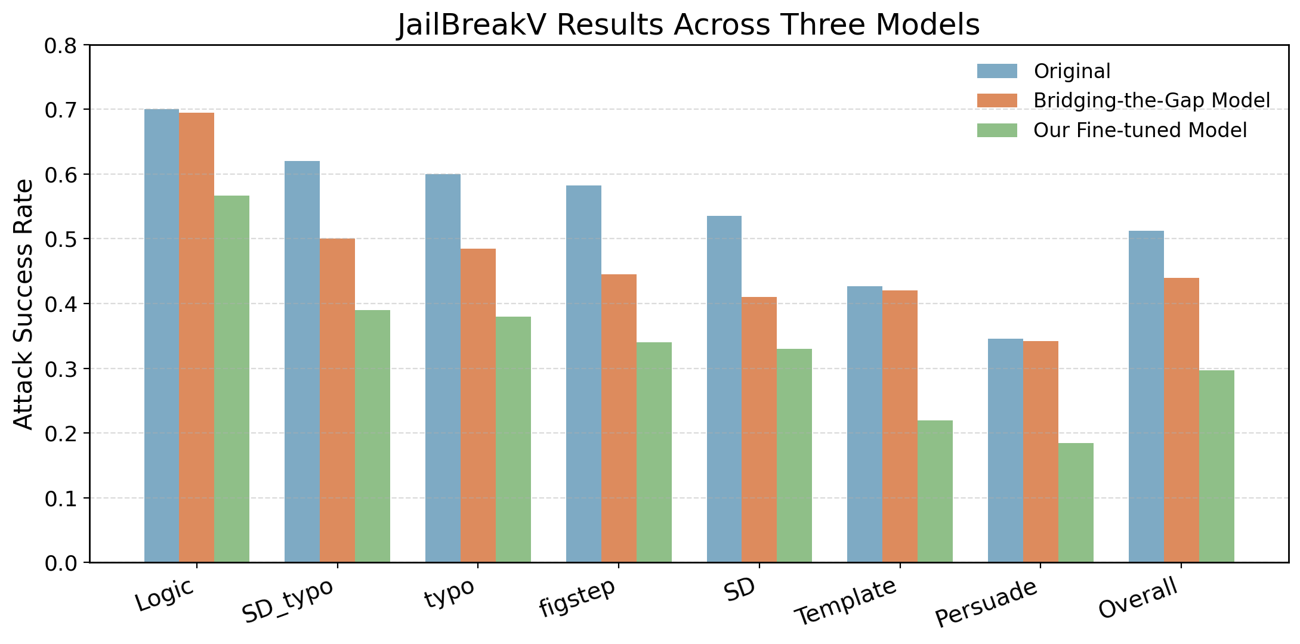
Table 6. JailBreakV per-attack results across three models
Attack Format | Original ASR | Bridging-the-Gap ASR | Our Fine-tuned ASR
Logic | 0.700 | 0.695 | 0.567
SD_typo | 0.620 | 0.500 | 0.390
typo | 0.600 | 0.485 | 0.380
figstep | 0.582 | 0.445 | 0.340
SD | 0.535 | 0.410 | 0.330
Template | 0.427 | 0.420 | 0.220
Persuade | 0.346 | 0.342 | 0.185

The `Bridging-the-Gap` style model reduces the overall ASR from `0.512` to `0.440`, which is only a moderate improvement. More importantly, the improvement is uneven. It performs better on several vision-related or mixed attack formats, such as `SD_typo`, `typo`, `figstep`, and `SD`, but it almost does not improve `Logic`, `Template`, and `Persuade`. This suggests that alignment-focused unsafe concept training alone is not sufficient for robust jailbreak defense.
Our fine-tuned model shows a stronger and more balanced improvement. The overall ASR decreases to `0.297`, which is lower than both the original model and the `Bridging-the-Gap` style model. `Logic` remains the hardest format after fine-tuning, but our model still reduces it from `0.700` to `0.567`. For `Template` and `Persuade`, where the `Bridging-the-Gap` style model almost stays at the original level, our method reduces ASR to `0.220` and `0.185` respectively.
These results support the main design choice of our project. A method that only improves the modality gap can make the model better at recognizing unsafe visual concepts, but it may still fail when the jailbreak is mainly carried by text instructions or persuasive attack structures. Our boundary-aware training and preference optimization are therefore useful because they strengthen the final response behavior, not only the recognition ability.
From a practical perspective, this three-model comparison is important because it separates two questions. The first question is whether a model can align visual unsafe concept recognition with safer responses. The second question is whether that safety behavior remains stable under adversarial jailbreak prompts. The `Bridging-the-Gap` style model mainly helps the first question, while our method brings a clearer improvement on both.
3.9 Summary Comparison
For clearer comparison, Table 7 summarizes the main results across the original model, the `Bridging-the-Gap` style model, and our fine-tuned model.
Table 7. Summary of main three-model comparison
Benchmark | Metric | Original | Bridging-the-Gap Model | Our Fine-tuned Model | Main Observation
UnsafeConcepts | Alignment | 0.292 | Improved alignment-focused behavior | 0.699 | Our method strongly reduces the modality gap
JailBreakV | Overall ASR | 0.512 | 0.440 | 0.297 | Our method gives the strongest jailbreak robustness
JailBreakV | Text-heavy attacks | High ASR | Almost unchanged | Clearly reduced | Alignment-only improvement is not enough
JailBreakV | Overall ASR | 0.512 | 0.297 | -0.215

From this table, we can see that our method achieves two goals at the same time. On the one hand, it keeps perception and text-only ability largely stable while greatly improving unsafe concept alignment. On the other hand, it reduces jailbreak attack success more clearly than the `Bridging-the-Gap` style model. This balance is important because a safety method should not simply make the model refuse everything, and it should also remain effective when attacks are expressed through text-heavy or mixed multimodal formats.
3.10 Discussion
The results support our revised assumption that unsafe concept alignment and jailbreak robustness are related but not identical. The baseline model has a strong perception score but weak alignment score, which means that safety failure is not only caused by poor visual recognition. The `Bridging-the-Gap` style model addresses this alignment issue to some extent, but its `JailBreakV` performance shows that modality-gap reduction alone does not guarantee strong robustness. After our fine-tuning, the alignment score increases greatly, and the jailbreak ASR also decreases more clearly. This indicates that strengthening the model's internal safety boundary at the response level is necessary for broader robustness.
At the same time, the results also show that not all attack formats become easy. `Logic` remains relatively strong even after fine-tuning. This means some forms of jailbreak are still difficult and may require stronger reasoning-level defense or more targeted data construction in future work.
Another point worth discussing is that our method does not rely on a heavy external defense system. This makes the method easier to integrate into the model itself. For a practical project setting, this is a meaningful advantage. The limitation, however, is that model-level alignment alone may still not fully solve all extreme attack cases. Therefore, future work can consider combining internal alignment with lightweight external checking modules.
There is also a trade-off that should be mentioned. When a model becomes safer, there is always a risk that it may become too conservative. In our experiments, perception and text-only performance remain stable, which suggests that this problem is not very serious in the current setting. Still, this is an issue worth paying attention to in future work, especially if the training data becomes more refusal-heavy.
4. Conclusion, Discussion and Future Work
In this project, we studied the safety behavior of `LLaVA-1.5-7B` from two related aspects: unsafe concept alignment and multimodal jailbreak robustness. We first evaluated the original model on `UnsafeConcepts` and found a clear modality gap. We then used a `Bridging-the-Gap` style comparison model to test whether improving this gap is already enough for jailbreak defense. The result shows that it is not enough: its overall `JailBreakV` ASR is still `0.440`, and text-heavy attacks such as `Logic`, `Template`, and `Persuade` remain close to the original model.
To improve this situation, we applied a multimodal safety alignment strategy based on boundary-aware data construction, response refinement, supervised fine-tuning, and a small preference optimization stage. The post-fine-tuning results show that the method is effective. On `UnsafeConcepts`, the alignment score improved from `0.292` to `0.699`, while perception and text-only performance remained stable. On `JailBreakV`, the overall attack success rate dropped from `0.512` for the original model and `0.440` for the `Bridging-the-Gap` style model to `0.297` for our fine-tuned model.
The response-level analysis also supports this conclusion. As shown in Figure 6, the proportion of `SAFE` responses increases from `32%` before alignment to `71%` after alignment, while `UNSAFE` responses decrease from `41%` to `12%` and `BAD` responses decrease from `27%` to `17%`. This indicates that the improvement is not only reflected in benchmark scores, but also in the actual distribution of generated response types.
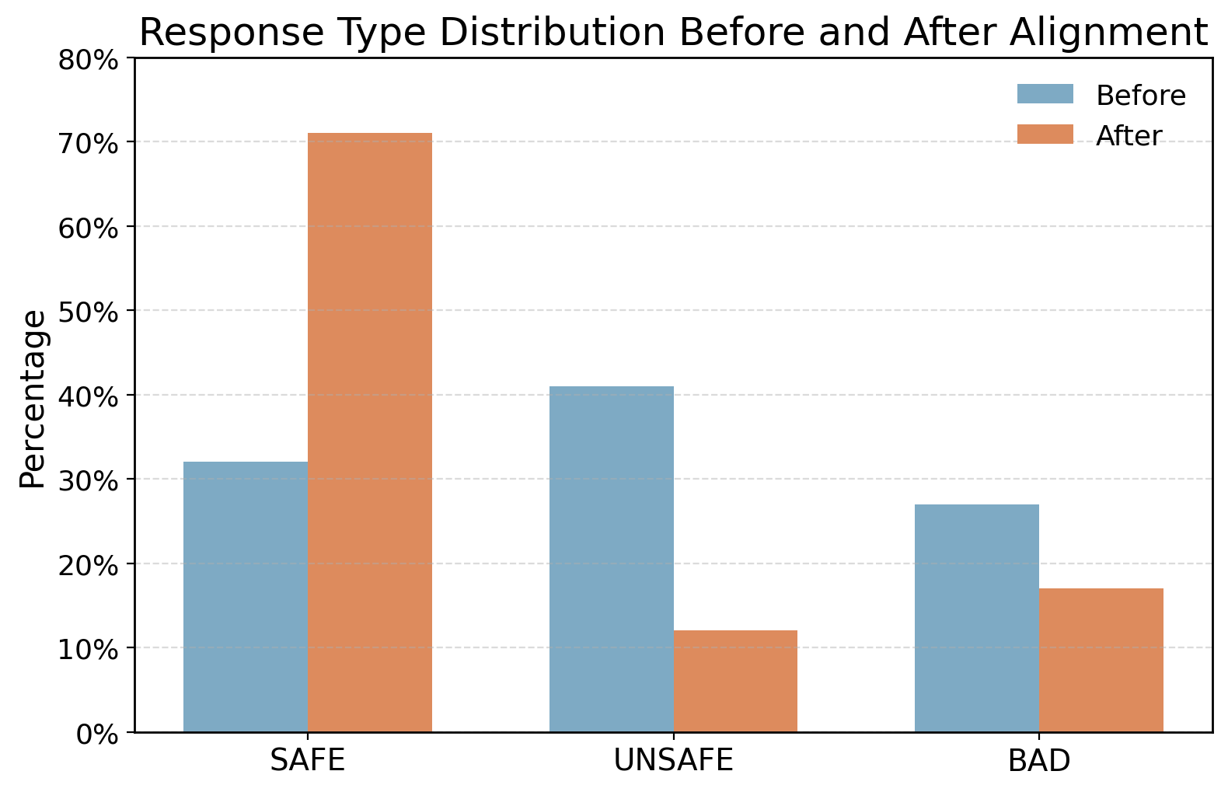
Figure 6. Response type distribution before and after alignment.
These results show that improving the model's internal multimodal safety boundary can help not only on a mechanism-oriented benchmark, but also on a practical jailbreak benchmark. In this sense, our project suggests that modality-gap reduction is a useful starting point, but stronger response-level alignment is needed to obtain reliable jailbreak robustness.
There are still several limitations in the current work. First, we only used one target model, `LLaVA-1.5-7B`, so the generalization of the method to other VLMs still needs further study. Second, although the results improved a lot, some attacks such as `Logic` remain difficult. Third, our project mainly focused on final model behavior and benchmark results, while more detailed ablation studies were not fully explored.
For future work, we plan to improve the method in several directions. One direction is to expand the boundary-aware training data and include more difficult text-heavy and cross-modal conflict cases. Another direction is to conduct more detailed analysis on why some attack types remain strong after fine-tuning. We also want to test whether the same method can be transferred to stronger or larger multimodal models. Finally, it would be valuable to combine model-level safety alignment with a lightweight external verification module for more robust practical deployment.
References
[1] Y. Qu, Z. Wang, Y. Zhang, Y. Wang, and H. Wang, "Bridging the Gap in Vision Language Models in Identifying Unsafe Concepts Across Modalities," arXiv preprint arXiv:2507.11155, 2025.
[2] W. Luo, X. Liu, Y. Li, J. Wang, and Y. Liu, "JailBreakV-28K: A Benchmark for Assessing the Robustness of MultiModal Large Language Models against Jailbreak Attacks," arXiv preprint arXiv:2404.03027, 2024.
[3] Y. Zhang, L. Chen, G. Zheng, Y. Gao, and X. Qiu, "SPA-VL: A Comprehensive Safety Preference Alignment Dataset for Vision-Language Models," CVPR, 2025.
[4] H. Zhang, Y. Zhou, J. Liu, and X. Wang, "Unraveling and Mitigating Safety Alignment Degradation of Vision-Language Models," arXiv preprint arXiv:2410.09047, 2024.
[5] H. Liu, C. Li, Q. Wu, and Y. J. Lee, "Visual Instruction Tuning," NeurIPS, 2023.
[6] E. J. Hu, Y. Shen, P. Wallis, Z. Allen-Zhu, Y. Li, S. Wang, L. Wang, and W. Chen, "LoRA: Low-Rank Adaptation of Large Language Models," ICLR, 2022.
[7] R. Rafailov, A. Sharma, E. Mitchell, C. D. Manning, C. Finn, and S. Ermon, "Direct Preference Optimization: Your Language Model is Secretly a Reward Model," NeurIPS, 2023.
[8] X. Wang, Z. Chen, Y. Li, and H. Wang, "MM-SafetyBench: A Benchmark for Safety Evaluation of Multimodal Large Language Models," arXiv preprint arXiv:2311.17600, 2023.
[9] Y. Gong, Y. Zhang, H. Xu, and B. Li, "FigStep: Jailbreaking Large Vision-Language Models via Typographic Visual Prompts," arXiv preprint arXiv:2311.05608, 2023.
[10] B. Li, J. Chen, W. Wang, and H. Wang, "LLaVA-RLHF: Aligning Large Multimodal Models with Reward Feedback," arXiv preprint arXiv:2311.09679, 2023.
[11] N. Bai, T. Xie, Y. Zhou, and H. Li, "Constitutional AI: Harmlessness from AI Feedback," arXiv preprint arXiv:2212.08073, 2022.
[12] X. Zhao, H. Wang, Y. Chen, and S. Liu, "MMJ-Bench: A Benchmark for Multimodal Jailbreak Evaluation," arXiv preprint arXiv:2403.06166, 2024.
[13] J. Lin, P. Zhang, X. Li, and Y. Qiao, "LLaVA-NeXT: Improved Visual Instruction Tuning for Large Vision-Language Models," arXiv preprint arXiv:2401.04658, 2024.
[14] Y. Dong, S. Zhao, B. Yang, and H. Wang, "Safety Tuning for Multimodal Large Language Models: A Survey," arXiv preprint arXiv:2406.11211, 2024.

